Faith
David Nguyen
A3

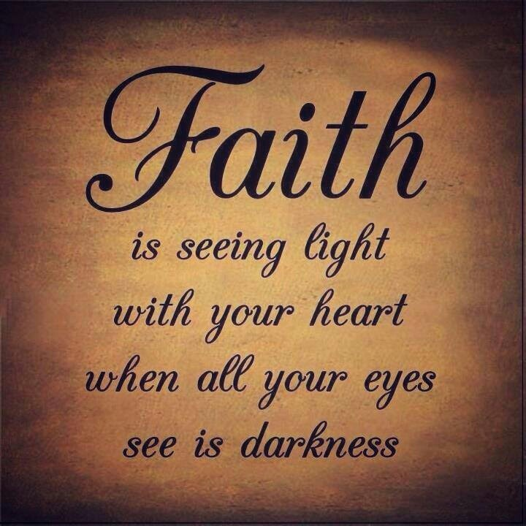

Dear God,
Something horrible just happen to me, all I want to do is kill myself because the pain that I’m feeling right now is getting worst and I can’t take this pain anymore. It stared a out like normal day for the both of us until I saw my girlfriend with another guy, I thought that I was mistaken it for another person or that my mind was playing trick on me so I turn the car around to go see if that was really my girlfriend and sadly it was, I can still remember it like it was just yesterday even though it happen three weeks ago, she was in his arm and they were kissing with the feeling of love behind it, a feeling that she never give to me.
After seeing that I took a picture just in case if she lies to me than I have something to fall back on, the next day came and I came over to her house to hang out with her than I ask her “what did you do yesterday?” And she says “I really didn’t do anything much yesterday but just seating around watching a movies and drinking tea” why? Then I ask her again and she says the same thing, right at that moment my heart just stop for a moment and I ask myself why would she lie to me?? Then I ask her why did she cheat on me with other guy and she says “what are you talking about?” acting like she didn’t do anything, I took my phone out and show her the picture that I took yesterday when I saw her with that guy, she look at me with an eyes of surprise and she says “I’m so sorry baby, I know what I did was wrong and I promise to you that I will never do it again.” I look at her and say okay I forgive you but this is the only time that I will forgive you.
Two week past by and everything was good, we didn’t get into fight and we see each other every day, it feel really good seeing your girlfriend and getting to hug her and kiss her, than everything went downhill on the third week, it started on a Friday morning when I was driving to my work place than all of a sudden I saw her car parking in front of a hotel waiting for someone so I turn my car around and find a place where I can see her but she can’t see me, I waited for about 20 to 30 minute until I see a black Bmw come in and park next to her car, than a guy came out the same guy from the picture . That’s when my faith just went away and I know that this relationship was nothing but a lie and that I was being played this whole time. The next day came and I was still thinking about what had just happen and I feel so sad actually because I thought that she was the one for me but she wasn’t, so I call her up and told her to meet me in person so that we can talk, later that day we meet up and I say “it’s over between us and then I just walk away and start my new life again
. 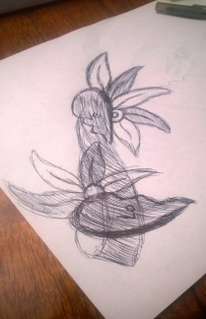

She
She was there for me when I broke my legs.
She was there for me when I cry for the first time.
She was there for me when I had a good day and a bad day.
She was the only one that has faith in me when no one else did.
She was there when I had my first heart break.
She was there for me when I got down on one knee.
She was the one that carry my kids for 9 month.
She was there when my kids saw light for the first time.
She is the strongest person that I have meet and got the honor to call her my wife.
But then… everything went dark for her and she was lying in a bed with a white sheet covering her from the waist down, as I saw her I just got sad because she was there for me so many time and now I can’t do anything to help her feel better, so I walk over and give her one last kiss and say I love you, three word that I know I can never say to her again, with every ounce of energy in her body she say I love you and close her eye one last time.
The Interview
Reporter; So what does it feel like being lost in the forest for 2 in a half month??
Survivor; to be honest with you it feel so horrible, with no food, water, and when you are hungry than you have to fight with other animal to eat, and the animal in the forest is so deadly with their big teeth and venoms that can kill you within an hour or two.
Reporter; what was the one thing that keeps you alive and have faith in being alive??
Survivor; there was a lot that keep me going but the one thing that keep me going was my family and getting to see there all that I have so I my goal was to stay alive until someone found me.
Reporter; who was there to help you get out of the forest??
Survivor; it was my friend that help me got out of the situation, and I have to trust him because he was the only person that was there, and there was my dog there to help me because when my friend went out to look for help he was there with me and comfort me when I was alone.
Reporter; what was the worst thing that happens to you in the forest??
Survivor; let me think, okay there was this one time when I was seating there and I turn around and all of a sudden I saw a king seating there three feet away from me, it was the most terrifying thing that can happen to me I promise you.
Reporter; do you have any advice that you want to give to the viewer??
Survivor; when you are lost in a forest, the first thing that you need is a fire because it will help you in so many thing, the second thing that you will need is a place to sleep, the third thing that you will need is something to help you hunt and to protect yourself, and the last thing that you will need is something to send out a signal. And get to know your surrounding it will help you a lot.
Reporter: well thank you for your time.
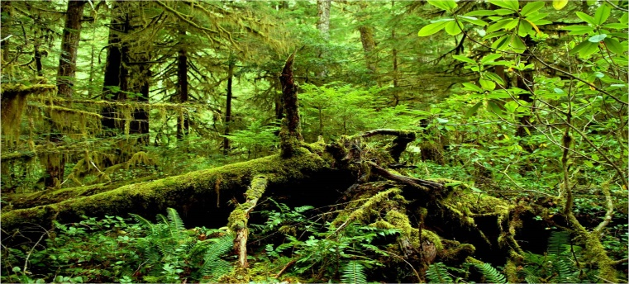

The color blue
May 2, 2006
I’m seating here alone with nothing to do, to eat, and to drink, everywhere I turn I see nothing but the color blue, and everything out here can kill me within min so I have to be on my toe at every hour and if I mess up even one time than is over for me.
May 12, 2003
It’s been a week seen I’m out here and nothing much happen but me trying to stay alive from the storm, the big wave, and the shark that keep attacking me because they want to eat me
.May 27, 2003
It’s been almost 2 week seen I wrote in here but a lot happen seen I was here, but I saw a plane fly past me and there was nothing that can do so that the plane can see me and know that I’m here.
June 8, 2003
It’s been a month seen my ship got burn down and is going wrong for me, I got sick three time and almost got eaten 2 time by those dam shark and I was so thirsty but I couldn’t drink the water around me because it’s salts water and if I drink it, my whole body will get sick and that’s the worst thing that can happen to me.
June 18, 2003
It’s been over a month in a half and still nobody is out here looking for me, as the time pass I start losing faith that I will ever be safe and that someone will find me in this big ocean, and how my condition is right now I feel that I’m going to die soon so this may be my last writing so if you find this book and you read it than tell my wife that I really love her and that I’m so sorry for leaving her all alone in this world and tell my kids that I’m sorry.
The Report
Case title; broken
Day and time; July 5, 2004
Incident type; a boy got heart broken and hang himself.
People involved; a young man, two police officer, and the neighbor.

Officer Report.
It was a late summer day when I got a phone call from HQ saying that I need to go to this address and check out the situation, when I got there I knock on the door to see if anyone was home than all of a sudden the door just open so I walk in and see a boy with a rope around his neck and was 20 feet above the ground, so I call for backup and when they got there we got the body down too see who was it than I walk around to ask if anyone know who live here and the people say that it was a young man that live here but he stop going outside anymore so they didn’t know what happen to him, when we got the body down a paper fall out of his pocket so I open it and it say,
If anyone read this letter than I’m not on this earth anymore, I been thinking about doing this for a long time but the only thing that keep me from not doing this was my girlfriend, I didn’t want her to be sad and she was everything to me but my whole world came down when I say her cheating on me not just one time but she did it two time, I just can’t stand the pain that’s in my heart anymore so killing myself is the best way to help me.
He wrote this before he hangs himself, so we call his parent to ask if they knew where the girl was, so that we can go tell her the bad news. When we got the phone call from the parent we when to her house and told her the bad news and she started to cry for what she had done.
The Conversation
The officer; hey there miss, we’re here to tell you that your ex-boyfriend hang himself two days ago
Girlfriend; how can this happen?
The officer; I’m sorry if this make you upset but we just want you to know that there was a letter that fall out when we got his body down.
Girlfriend; can I see the letter please?
The officer; okay here you go.
The girl friend take a couple of min to read the letter than say “ no I didn’t mean to cheat on him, I feel so bad now, because of me he’s not here anymore.”
The officer; we’re not going to say anything because it’s not our business but you should be sorry, he was a good guy and he didn’t do anything to you but love you with all of his heart and you go off cheating on him.
Girlfriend; IM SORRY, IM SORRY
Two days later the girlfriend hang herself because she couldn’t live knowing that she was the one that kill him and put sadness in his parent heart forever

End Notes
Dear god; this one is about a guy that saw his girlfriend cheated on him not just one time but twice and it talk about the feeling that he had when he saw her and how he react to it. And it also talk about the faith that he had with her start going down after he found out that she broke the promise that they made with each other.
She; this one is a poem that talk about a guy that was seating in the hospital room losing faith in his wife staying alive in the final min that they have with each other and how he got mad at himself for not being able to help her when she needed him the most.
The Interview; this one is about an interview that a man have with a reporter after being lost in the forest and it talk about what was some of the thing that he put faith in to help him survive in the forest after being lost for 2 in a half month
The color blue; this one talk about a man being stuck in the ocean after his ship was burn down and how he lost his faith in getting out alive after 1 in a half month of no food and no water to drink, it also show how his faith was strong at first than it start getting weaker as the day passed by.
The report; this one talk about a young man losing faith after his girlfriend cheated on him two time so he decide to kill himself so that all the pain can just go away and that he doesn’t have to live with those bad memories for the rest of his life.
The conversation; this one is about a conversation that the officer have with the girlfriend and how she lost faith in living after hearing that she was the one that kill the guy and put sadness in the parent heart so she ended her life.

